BTEC Learner Assessment Submission and Declaration

When submitting evidence for assessment, each learner must sign a declaration confirming that the work is their own.

Learner Name: | Sebastian Archer
Assessor Name: | Karl Evans
BTEC Programme Title: | BTEC L2 Information Creative Technology
Unit or Component Number and Title: | Unit 21 – A Technology Business
Assignment Title: | Assignment 2 – A prototype technology-based product or service
Date Assignment Submitted:

Please list the evidence submitted for each task. Indicate the page numbers where the evidence can be found or describe the nature of the evidence (e.g. video, illustration).

Assignment task reference | Evidence submitted
A.P1
A.M1
A.D1

Learner declaration

I certify that the work submitted for this assignment is my own. I have clearly referenced any sources used in the work. I understand that false declaration is a form of malpractice.

Learner signature: Date:

Task 1

Gaming Statistics

This app will show statistics on different games and what players are doing on them, like how many players are active, the current kill rate for different parts of the games, and different server statistics. People can also leave reviews on different games within the app so other people can see everyone else’s opinions.

Features/Functions
Online Count In-game / On a server
Leave reviews for games
Leave reviews for servers
Ads supporting revenue for keeping the app up / optional purchase to get rid
Live Server Monitoring for supported games
Keep up to date with events for supported games

Benefits
Keep an eye on your server
See what game is most popular

The Unique Selling point for my app is that it will be able to track as many games as you want at one time without restrictions.

It will probably be a one-time price of £4.99

I have chosen to pursue this app because we need more apps like this in the gaming industry, while there aren’t many that allow unrestricted access.

Task 2:

https://tracker.gg Benefits

Huge Potential Market Size, already popular.
It has custom content like custom stream overlays for viewers on streams to see live statistics.

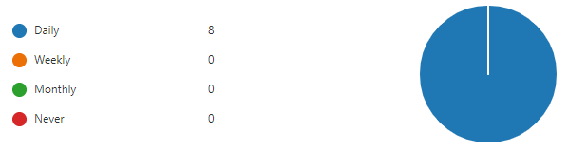

Here is a statistic from my form, the question that was asked was “How often do you play games?”. With a completely one-sided score, only the daily statistic was chosen by everyone who completed the form.

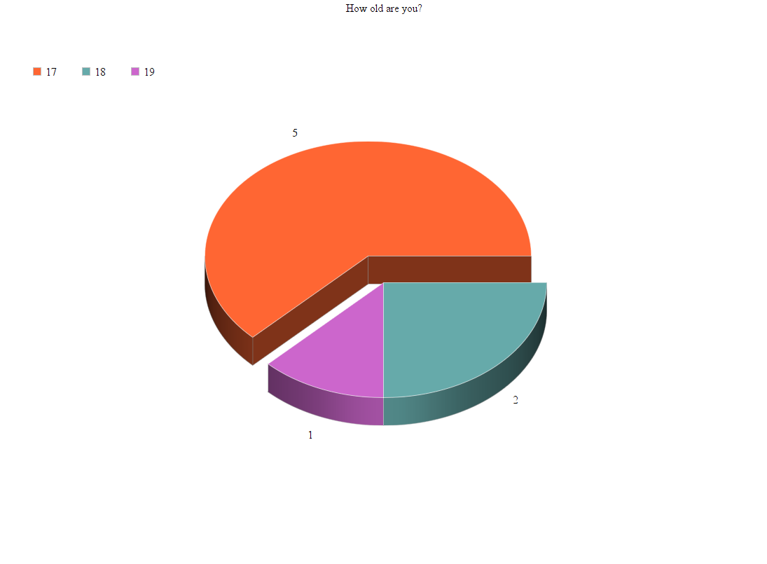
Here is a Pie Chart showing the average age of those who contributed to the form.

Orange represents the 17 age group.
Blue represents the 18 age group.
Purple represents the 19 age group.

The statistics were:

17: 5
18: 2
19: 1

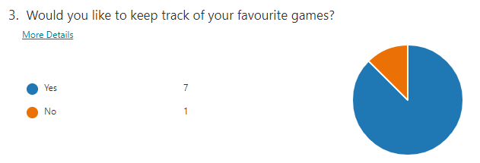
Out of 8 people I asked, at least 7 would like to be able to keep track of their favourite games, wherever they are and whenever they want. This is an extremely useful to know because it can help to know where to aim development into our app.

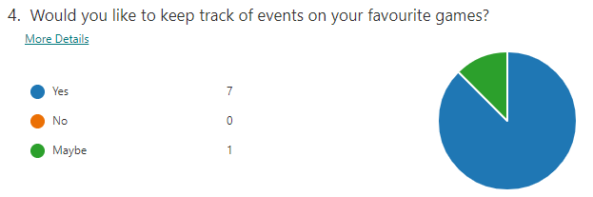

Out of 8 people I asked, at least 7 would like to be able to keep track of events in their favourite games, wherever they are and whenever they want. This is an extremely useful to know because it can help to know where to aim development into our app.

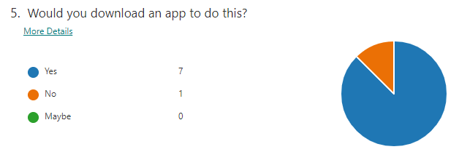

Out of 8 people I asked, 7 would be up to downloading an app for the functionality and services this app would provide you.

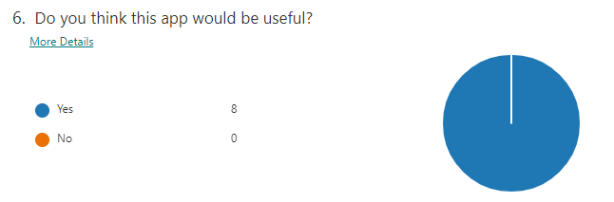
It appears that out of everyone who responded to my survey, they all think my app would be useful. This is extremely useful to know because it means that I can estimate a lot of downloads and usage for my app.

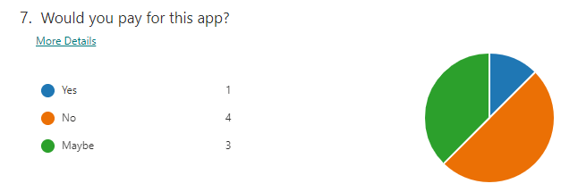
When asking if people would like to pay for my app, 3 said they might pay for it, this means I would need to perhaps persuade people on how my app would benefit them, more than other apps.

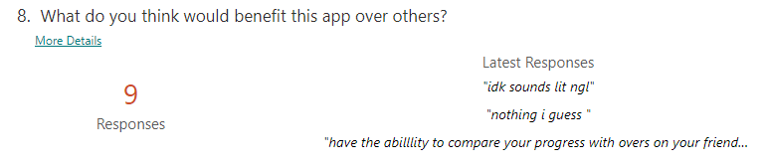

One person has mentioned that having the ability to compare progress with a friend would be beneficial for this app, so I will take this suggestion into account when designing my app.

